**Comprehensive Full Report**

**Introduction:**

In this report I will be providing a comprehensive trend analysis of five different companies which include Apple (AAPL), Microsoft (MSFT), Costco (COST), Federal Signal Corporation (FSS), and Johnson & Johnson (JNJ). This report includes financial data and ratios from 2019 through the latest available year. I have included key financial performance metrics such as revenue, net income, total assets, total liabilities and core financial ratios such as net profit margin, current ratio, quick ratio, debt-to-equity, return on equity to identify trends. Also, I will be interpreting association rules generated by an Apriori algorithm on these metrics to see how patterns in the data. This analysis tends to focus on clarity, key insights, and implications for decision-making.

**Methodology:**

In terms of methodology, I have utilized historical financial data provided for fiscal years 2019 through 2024. The data includes annual revenue, net income, total assets, and total liabilities, from which various financial ratios were calculated. An Apriori association rule was applied for each company by classifying each ratio as high or low which will be discussed in the findings of the report. I will be focusing on patterns that are 100% true in the sample which means they have a very strong relationship. However, if there were strange low values in certain years maybe due to incomplete data, I have taken that into account however in this report those odd years did not change the overall patterns. Thus, by comparing patterns across all companies and I will then discuss these connections for making financial decisions. By grouping each financial ratio as high or low and using the patterns it allowed for better understanding the company’s performance trends and support any financial decisions.

**Apple (AAPL) Analysis and Findings**

In terms of Apple’s analysis and findings based on the data it has shown a strong revenue and profits but also indicates some growing risks. The revenue and profits have rebounded from $383.3B in 2023 to $391.0B in 2024, close to its 2022 high. Net income stayed high, in the mid-$90B range. Profit margins improved after 2020, stabilizing around 25%, pointing to better efficiency or pricing. Total assets stayed about the same $350–365B, but liabilities jumped from $248.0B in 2019 to $308.0B in 2024 meaning Apple took on more debt or obligations. Apple’s current ratio fell from 1.54 in 2019 to 0.87 in 2024, and the quick ratio dropped from 1.50 to 0.83. This means Apple’s cushion for covering short-term debts is thinner. The debt-to-equity ratio soared from 2.74 (2019) to 5.41 2024 Apple has dramatically increased its use of debt or reduced its equity, likely through share buybacks. As a result, ROE (return on equity) exploded to 164.59% in 2024, far above most companies. Apple keeps delivering high profits and revenue growth, powered partly by taking on more debt and returning cash to shareholders. This boosts shareholder returns (ROE) but means Apple has less short-term liquidity and much higher leverage making it more financially aggressive than in the past. In terms of the Apriori rule whenever Apple had a high net profit margin meaning it kept a big share of revenue as profit, its return on equity (ROE) was also high, which does make sense because with strong profits and less equity due to buybacks, returns for each dollar of equity were enormous. The patterns also show that when Apple’s leverage rose, its liquidity shrank, and when profit margins rose, so did ROE.

**Full Financial Data for AAPL**

| **Fiscal Year** | **Revenue** | **Net Income** | **Total Assets** | **Total Liabilities** |
| --- | --- | --- | --- | --- |
| 2024 | 391,035,000,000 | 93,736,000,000 | 364,980,000,000 | 308,030,000,000 |
| 2023 | 383,285,000,000 | 96,995,000,000 | 352,583,000,000 | 290,437,000,000 |
| 2022 | 394,328,000,000 | 99,803,000,000 | 352,755,000,000 | 302,083,000,000 |
| 2021 | 365,817,000,000 | 94,680,000,000 | 351,002,000,000 | 287,912,000,000 |
| 2020 | 64,698,000,000 | 12,673,000,000 | 323,888,000,000 | 258,549,000,000 |
| 2019 | 64,040,000,000 | 13,686,000,000 | 338,516,000,000 | 248,028,000,000 |

**Financial Ratios for AAPL**

| **Fiscal Year** | **Net Profit Margin** | **Current Ratio** | **Quick Ratio** | **Debt to Equity** | **ROE** |
| --- | --- | --- | --- | --- | --- |
| 2024 | 0.2397 | 0.8673 | 0.8260 | 5.4088 | 1.6459 |
| 2023 | 0.2531 | 0.9880 | 0.9444 | 4.6735 | 1.5608 |
| 2022 | 0.2531 | 0.8794 | 0.8472 | 5.9615 | 1.9696 |
| 2021 | 0.2588 | 1.0746 | 1.0221 | 4.5635 | 1.5007 |
| 2020 | 0.1959 | 1.3636 | 1.3251 | 3.9570 | 0.1940 |
| 2019 | 0.2137 | 1.5401 | 1.5013 | 2.7410 | 0.1512 |

**Top Association Rules for AAPL**

| **Antecedents** | **Consequents** | **Support** | **Confidence** | **Lift** |
| --- | --- | --- | --- | --- |
| (net_profit_margin_High) | (roe_High) | 0.6667 | 1.0 | 1.5 |
| (roe_High) | (net_profit_margin_High) | 0.6667 | 1.0 | 1.5 |
| (quick_ratio_High) | (current_ratio_High) | 0.3333 | 1.0 | 3.0 |
| (current_ratio_High) | (quick_ratio_High) | 0.3333 | 1.0 | 3.0 |
| (debt_to_equity_Low) | (current_ratio_High) | 0.3333 | 1.0 | 3.0 |
| (current_ratio_High) | (debt_to_equity_Low) | 0.3333 | 1.0 | 3.0 |
| (debt_to_equity_Low) | (quick_ratio_High) | 0.3333 | 1.0 | 3.0 |
| (quick_ratio_High) | (debt_to_equity_Low) | 0.3333 | 1.0 | 3.0 |
| (debt_to_equity_Low, quick_ratio_High) | (current_ratio_High) | 0.3333 | 1.0 | 3.0 |
| (debt_to_equity_Low, current_ratio_High) | (quick_ratio_High) | 0.3333 | 1.0 | 3.0 |

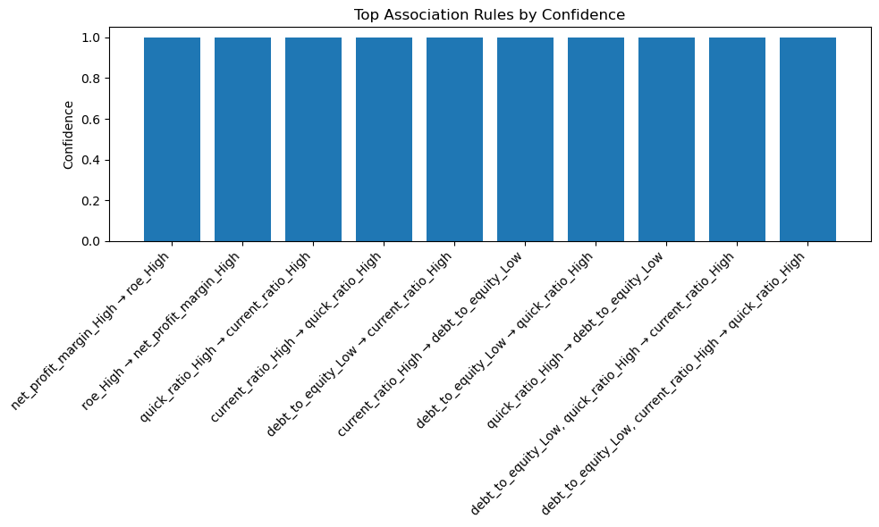

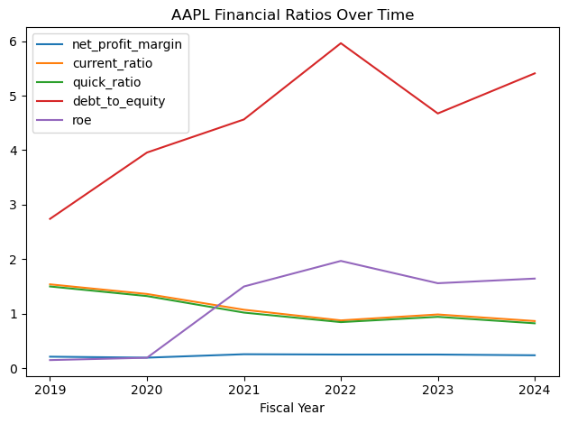

**Microsoft (MSFT) Analysis and Findings**

In terms of MSFT analysis and findings the data shows annual revenue rose from $168.1B in 2021 to $281.7B in 2025. Net income also grew from $61.3B to $101.8B, with particularly rapid gains in the last two years. This showcases Microsoft’s ability to scale both revenue and profits at an accelerating pace. Microsoft has maintained net profit margins in the mid 30% range each year, indicating it runs a highly efficient and profitable business even as it scales. Total assets nearly doubled from $333.8B to $619.0B, while liabilities increased more slowly from $191.8B to $275.5B. The company’s debt to equity ratio dropped from 1.35 to 0.80, signaling a stronger equity position and lower financial risk over time. Liquidity ratios current and quick declined from 2021 to 2025 but remained strong current ratio: 2.08 to 1.35, suggesting Microsoft used some excess cash for productive investments and shareholder returns not due to any distress. ROE started extremely high 43% in 2021–2022, then leveled to 29.6% in 2025. This moderation occurred because Microsoft built up equity, not because profitability decreased evidence of conservative and sustainable management. In terms of Apriori rule is reveals several important insights such as when Microsoft reduced its financial leverage, it did not harm ROE on the contrary, high returns came from strong business performance, not from taking on more debt. Also, high profitability and high ROE typically went hand-in-hand, showing efficient and effective use of resources. Thus overall, it shows financial strength and conservative risk management rather than relying on leverage or risky strategies to boost returns.

**Full Financial Data for MSFT**

| **Fiscal Year** | **Revenue** | **Net Income** | **Total Assets** | **Total Liabilities** |
| --- | --- | --- | --- | --- |
| 2025 | 281,724,000,000 | 101,832,000,000 | 619,003,000,000 | 275,524,000,000 |
| 2024 | 245,122,000,000 | 88,136,000,000 | 512,163,000,000 | 243,686,000,000 |
| 2023 | 211,915,000,000 | 72,361,000,000 | 411,976,000,000 | 205,753,000,000 |
| 2022 | 198,270,000,000 | 72,738,000,000 | 364,840,000,000 | 198,298,000,000 |
| 2021 | 168,088,000,000 | 61,271,000,000 | 333,779,000,000 | 191,791,000,000 |
| 2020 | 38,033,000,000 | 11,202,000,000 | 301,311,000,000 | 183,007,000,000 |
| 2019 | 33,717,000,000 | 13,187,000,000 | 286,556,000,000 | 184,226,000,000 |

**Financial Ratios for MSFT**

| **Fiscal Year** | **Net Profit Margin** | **Current Ratio** | **Quick Ratio** | **Debt to Equity** | **ROE** |
| --- | --- | --- | --- | --- | --- |
| 2025 | 0.361460 | 1.353446 | 1.346804 | 0.802157 | 0.296472 |
| 2024 | 0.359560 | 1.274955 | 1.265010 | 0.907661 | 0.328281 |
| 2023 | 0.341462 | 1.769167 | 1.745163 | 0.997721 | 0.350887 |
| 2022 | 0.366863 | 1.784607 | 1.745251 | 1.190679 | 0.436755 |
| 2021 | 0.364517 | 2.079994 | 2.050261 | 1.350755 | 0.431522 |
| 2020 | 0.294534 | 2.515765 | 2.489559 | 1.546921 | 0.094688 |
| 2019 | 0.391108 | 2.528839 | 2.499121 | 1.800313 | 0.128867 |

**Top Association Rules for MSFT**

| **Antecedents** | **Consequents** | **Support** | **Confidence** | **Lift** |
| --- | --- | --- | --- | --- |
| (current_ratio_High) | (quick_ratio_High) | 0.428571 | 1.00 | 2.333333 |
| (quick_ratio_High) | (current_ratio_High) | 0.428571 | 1.00 | 2.333333 |
| (debt_to_equity_Low) | (roe_High) | 0.571429 | 1.00 | 1.400000 |
| (net_profit_margin_High, debt_to_equity_Low) | (roe_High) | 0.428571 | 1.00 | 1.400000 |
| (roe_High) | (net_profit_margin_High) | 0.571429 | 0.80 | 1.120000 |
| (net_profit_margin_High) | (roe_High) | 0.571429 | 0.80 | 1.120000 |
| (roe_High) | (debt_to_equity_Low) | 0.571429 | 0.80 | 1.400000 |
| (debt_to_equity_Low) | (net_profit_margin_High) | 0.428571 | 0.75 | 1.050000 |
| (roe_High, net_profit_margin_High) | (debt_to_equity_Low) | 0.428571 | 0.75 | 1.312500 |
| (roe_High, debt_to_equity_Low) | (net_profit_margin_High) | 0.428571 | 0.75 | 1.050000 |

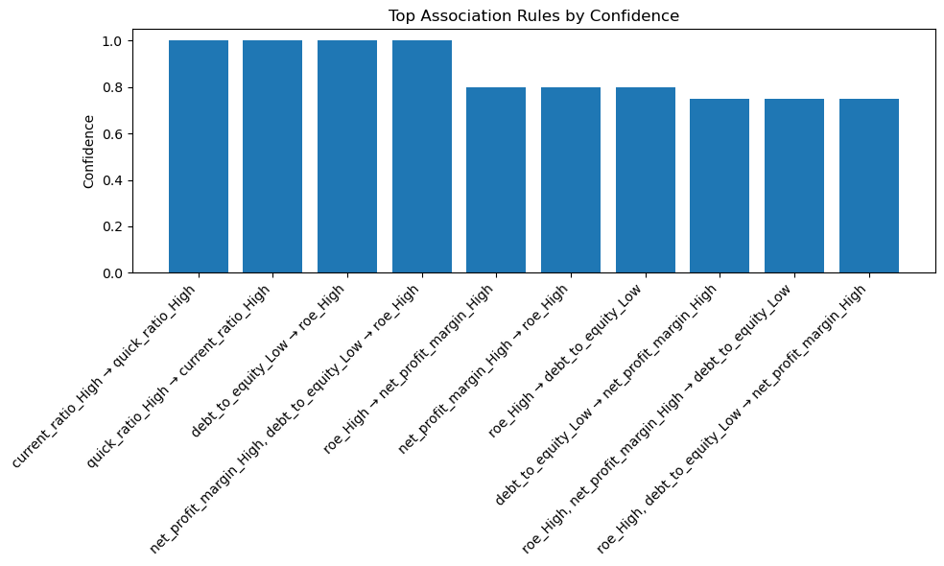

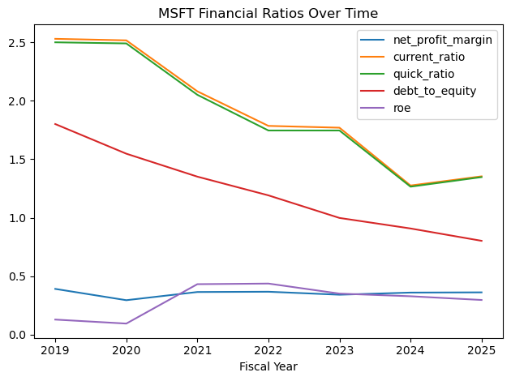

**Costco (COST) Analysis and Findings**

Costco’s financials from 2021 to 2024 reveal a company defined by steady growth, stable profitability and efficient use of capital. Its sales climbed from $195.9B in 2021 to $254.5B in 2024, showing robust, consistent annual growth. Its net income grew from $5.0B to $7.37B in the same period. However, Costco’s net profit margins remained thin but stable 2.5–2.9%, reflecting its business strategy of low prices and high sales volume. The ROE surged from just 7% before 2021 to 27–31% thereafter, indicating that shareholders are enjoying significantly higher returns likely due to strong profit growth. The current ratio stayed just about 1, and the quick ratio around 0.5, typical for retail. This means Costco keeps just enough liquidity to meet its short-term obligations, optimizing working capital and inventory but with no apparent liquidity stress. In terms of the Apirori rule analysis it reveals that the liquidity moves together when the current ratio is high its quick ratio is also high this is expected since both measure short-term financial health, and both rise when current assets increase. There is also an inverse relationship with leverage because strong current and quick ratio directly aligns with lower to debt to equity. When Costco holds more liquid assets, it tends to take on less debt, as observed in years like 2023.

**Full Financial Data for COST**

| **Fiscal Year** | **Revenue** | **Net Income** | **Total Assets** | **Total Liabilities** |
| --- | --- | --- | --- | --- |
| 2024 | 254,453,000,000 | 7,367,000,000 | 69,831,000,000 | 46,209,000,000 |
| 2023 | 242,290,000,000 | 6,292,000,000 | 68,994,000,000 | 43,936,000,000 |
| 2022 | 226,954,000,000 | 5,844,000,000 | 64,166,000,000 | 43,519,000,000 |
| 2021 | 195,929,000,000 | 5,007,000,000 | 59,268,000,000 | 41,190,000,000 |
| 2020 | 53,383,000,000 | 1,389,000,000 | 55,556,000,000 | 36,851,000,000 |
| 2019 | 47,498,000,000 | 1,097,000,000 | 45,400,000,000 | 29,816,000,000 |
|  |  |  |  |  |

**Financial Ratios for COST**

| **Fiscal Year** | **Net Profit Margin** | **Current Ratio** | **Quick Ratio** | **Debt to Equity** | **ROE** |
| --- | --- | --- | --- | --- | --- |
| 2024 | 0.028952 | 0.965655 | 0.439855 | 1.956185 | 0.311870 |
| 2023 | 0.025969 | 1.068368 | 0.572552 | 1.753372 | 0.251097 |
| 2022 | 0.025750 | 1.021814 | 0.462185 | 2.107764 | 0.283044 |
| 2021 | 0.025555 | 1.002174 | 0.519344 | 2.278460 | 0.276966 |
| 2020 | 0.026020 | 1.131863 | 0.639108 | 1.970115 | 0.074258 |
| 2019 | 0.023096 | 1.010673 | 0.520291 | 1.913244 | 0.070393 |

**Top Association Rules for COST**

| **Antecedents** | **Consequents** | **Support** | **Confidence** | **Lift** |
| --- | --- | --- | --- | --- |
| (current_ratio_High) | (quick_ratio_High) | 0.333333 | 1.0 | 3.0 |
| (quick_ratio_High) | (current_ratio_High) | 0.333333 | 1.0 | 3.0 |
| (current_ratio_High) | (debt_to_equity_Low) | 0.333333 | 1.0 | 1.5 |
| (quick_ratio_High) | (debt_to_equity_Low) | 0.333333 | 1.0 | 1.5 |
| (current_ratio_High, quick_ratio_High) | (debt_to_equity_Low) | 0.333333 | 1.0 | 1.5 |
| (current_ratio_High, debt_to_equity_Low) | (quick_ratio_High) | 0.333333 | 1.0 | 3.0 |
| (quick_ratio_High, debt_to_equity_Low) | (current_ratio_High) | 0.333333 | 1.0 | 3.0 |
| (current_ratio_High) | (quick_ratio_High, debt_to_equity_Low) | 0.333333 | 1.0 | 3.0 |
| (quick_ratio_High) | (current_ratio_High, debt_to_equity_Low) | 0.333333 | 1.0 | 3.0 |

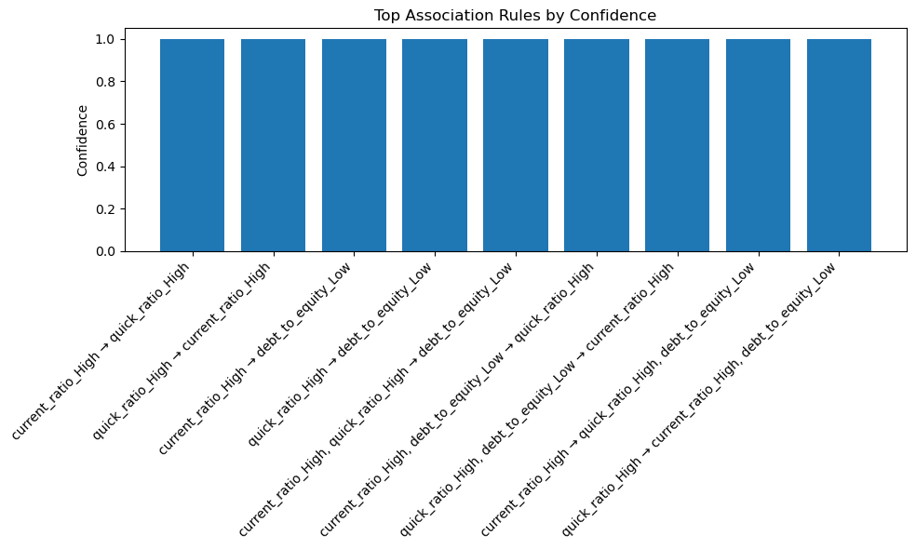

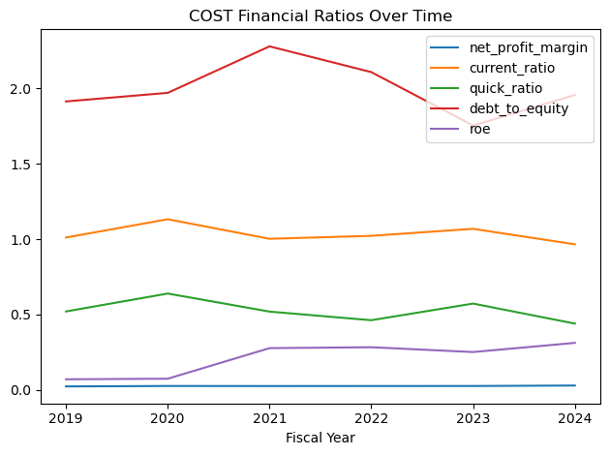

**Federal Signal (FSS) Analysis and Findings**

If we look at the data Federal Signal Corporation (FSS) has transformed itself into a much stronger and more profitable company from 2019 to 2024. Annual revenue grew steadily from $1.22B in 2019 to $1.86B in 2024. The real standout is profit: net income rose dramatically from $29.8M to $216.3M, reflecting big improvements in operations and cost management. Net profit margins improved from just 2.44% to 11.62%. This means FSS managed to retain much more of each dollar earned, likely through internal efficiencies. Assets rose alongside business growth, but liabilities grew much more slowly and even decreased in 2024. This means the company’s grew substantially, mainly from retained profits. FSS kept a very healthy current ratio 2.5–2.9 and a strong quick ratio above 1.1, showing a robust cushion to pay short-term bills. Return on equity ROE a key measure of profitability for shareholders jumped from 4.6% to 18.24%, thanks to much higher earnings on the growing equity base. In terms of the Apriori association rules in years when FSS had a high current ratio lots of liquid assets were also years with high profit margins. This means strong financial health and operational performance tended to occur at the same time. When FSS had high current and quick ratios indicating strong liquidity and high profit margins, it always achieved high return on equity (ROE). So, strong performance in liquidity and profitability directly translated into strong returns for shareholders. Lastly Keeping debt-to-equity low meaning less reliance on debt was consistently associated with high profit margins and high ROE. As FSS paid down debt and built equity, its profitability and shareholder return rose.

**Full Financial Data for FSS**

| **Fiscal Year** | **Revenue** | **Net Income** | **Total Assets** | **Total Liabilities** |
| --- | --- | --- | --- | --- |
| 2024 | 1,861,500,000 | 216,300,000 | 1,765,200,000 | 579,100,000 |
| 2023 | 1,722,700,000 | 157,400,000 | 1,620,500,000 | 618,600,000 |
| 2022 | 1,434,800,000 | 120,400,000 | 1,524,300,000 | 663,400,000 |
| 2021 | 1,213,200,000 | 100,600,000 | 1,366,100,000 | 582,100,000 |
| 2020 | 1,130,800,000 | 96,200,000 | 1,208,800,000 | 506,700,000 |
| 2019 | 1,221,300,000 | 29,800,000 | 1,165,500,000 | 523,900,000 |

**Financial Ratios for FSS**

| **Fiscal Year** | **Net Profit Margin** | **Current Ratio** | **Quick Ratio** | **Debt to Equity** | **ROE** |
| --- | --- | --- | --- | --- | --- |
| 2024 | 0.116197 | 2.657155 | 1.288255 | 0.488239 | 0.182362 |
| 2023 | 0.091368 | 2.912155 | 1.362615 | 0.617427 | 0.157102 |
| 2022 | 0.083914 | 2.944044 | 1.322438 | 0.770589 | 0.139854 |
| 2021 | 0.082921 | 2.529343 | 1.184859 | 0.742474 | 0.128316 |
| 2020 | 0.085073 | 2.732480 | 1.485849 | 0.721692 | 0.137018 |
| 2019 | 0.024400 | 2.251561 | 1.109863 | 0.816552 | 0.046446 |

**Top Association Rules for FSS**

| **Antecedents** | **Consequents** | **Support** | **Confidence** | **Lift** |
| --- | --- | --- | --- | --- |
| (current_ratio_High) | (net_profit_margin_High) | 0.666667 | 1.0 | 1.2 |
| (current_ratio_High, quick_ratio_High, net_profit_margin_High) | (roe_High) | 0.500000 | 1.0 | 1.2 |
| (roe_High, debt_to_equity_Low) | (net_profit_margin_High) | 0.333333 | 1.0 | 1.2 |
| (net_profit_margin_High, debt_to_equity_Low) | (roe_High) | 0.333333 | 1.0 | 1.2 |
| (debt_to_equity_Low) | (roe_High, net_profit_margin_High) | 0.333333 | 1.0 | 1.2 |
| (current_ratio_High, quick_ratio_High) | (roe_High) | 0.500000 | 1.0 | 1.2 |
| (roe_High, quick_ratio_High) | (current_ratio_High) | 0.500000 | 1.0 | 1.5 |
| (quick_ratio_High) | (current_ratio_High, roe_High) | 0.500000 | 1.0 | 1.5 |
| (current_ratio_High, debt_to_equity_Low) | (roe_High) | 0.333333 | 1.0 | 1.2 |
| (roe_High, debt_to_equity_Low) | (current_ratio_High) | 0.333333 | 1.0 | 1.5 |

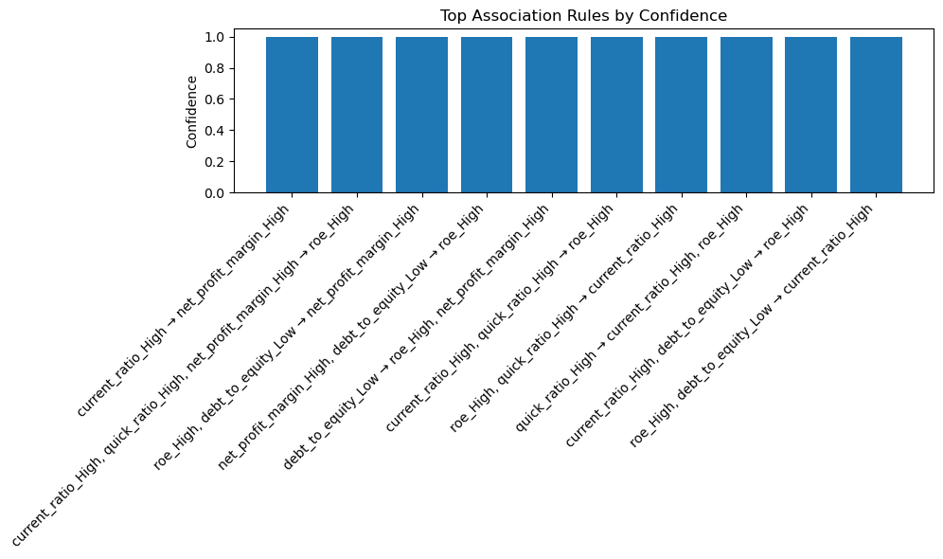

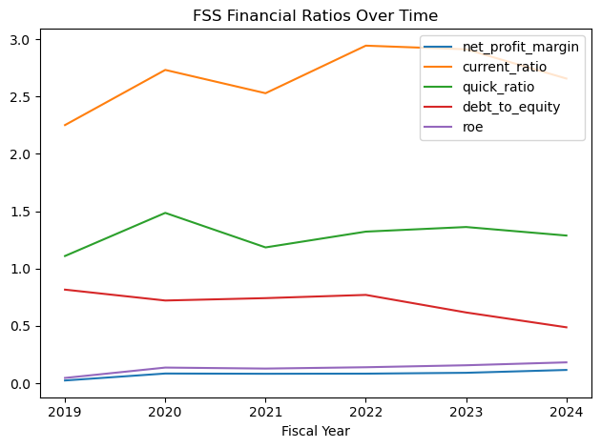

**Johnson & Johnson (JNJ) Analysis and Findings**

The most important highlights in the finding for JNJ is that from 2020 to 2022, JNJ’s revenue grew moderately from $82.6B to $94.9B, and net income followed a similar trend, peaking in 2021. But in 2024, revenue declined to $88.8B, and net income to $14.1B from the high point. Profit margins have historically been stable high-teens to low-20%s, showing strong underlying profitability. There was a dip in 2024 to about 15.8% was likely due to higher costs. Total assets and liabilities stayed in a steady range $174–187B assets, $98–111B liabilities through 2024. The ROE was strong 20–28% most years, highlighting solid profitability, however one exception was a large drop in 2023 due which could have been due to restructuring costs or the company was coming out of pandemic. Things that matter the most is the following company avoids excessive risks, maintains sufficient liquidity, and uses moderate debt to fund operations. Also, the fact that returns are consistent, and the company is resilient even during shocks or strategic changes. Whenever JNJ’s net profit margin was high, its current and quick ratios were also high. This means that in more profitable years, the company also enjoyed greater ability to cover short-term obligations, likely due to better cash generation and effective working capital management. High current ratios and high quick ratios typically appear in the same years, confirming that increases in overall liquidity.

**Full Financial Data for JNJ**

| **Fiscal Year** | **Revenue** | **Net Income** | **Total Assets** | **Total Liabilities** |
| --- | --- | --- | --- | --- |
| 2024 | 88,821,000,000 | 14,066,000,000 | 180,104,000,000 | 108,614,000,000 |
| 2023 | 21,395,000,000 | 4,049,000,000 | 167,558,000,000 | 98,784,000,000 |
| 2022 | 94,943,000,000 | 17,941,000,000 | 187,378,000,000 | 110,574,000,000 |
| 2021 | 93,775,000,000 | 20,878,000,000 | 182,018,000,000 | 107,995,000,000 |
| 2020 | 82,584,000,000 | 14,714,000,000 | 174,894,000,000 | 111,616,000,000 |
| 2019 | 20,747,000,000 | 4,010,000,000 | 157,728,000,000 | 98,257,000,000 |

**Financial Ratios for JNJ**

| **Fiscal Year** | **Net Profit Margin** | **Current Ratio** | **Quick Ratio** | **Debt to Equity** | **ROE** |
| --- | --- | --- | --- | --- | --- |
| 2024 | 0.158363 | 1.110729 | 0.863437 | 1.519289 | 0.196755 |
| 2023 | 0.189250 | 1.155849 | 0.914265 | 1.436357 | 0.058874 |
| 2022 | 0.188966 | 0.990896 | 0.767195 | 1.439691 | 0.233595 |
| 2021 | 0.222639 | 1.348317 | 1.118649 | 1.458938 | 0.282047 |
| 2020 | 0.178170 | 1.205775 | 0.985880 | 1.763899 | 0.232529 |
| 2019 | 0.193281 | 1.258870 | 1.008064 | 1.652183 | 0.067428 |

**Top Association Rules for JNJ**

| **Antecedents** | **Consequents** | **Support** | **Confidence** | **Lift** |
| --- | --- | --- | --- | --- |
| (net_profit_margin_High) | (current_ratio_High) | 0.333333 | 1.00 | 2.000 |
| (net_profit_margin_High) | (quick_ratio_High) | 0.333333 | 1.00 | 2.000 |
| (current_ratio_High) | (quick_ratio_High) | 0.500000 | 1.00 | 2.000 |
| (quick_ratio_High) | (current_ratio_High) | 0.500000 | 1.00 | 2.000 |
| (current_ratio_High, net_profit_margin_High) | (quick_ratio_High) | 0.333333 | 1.00 | 2.000 |
| (quick_ratio_High, net_profit_margin_High) | (current_ratio_High) | 0.333333 | 1.00 | 2.000 |
| (net_profit_margin_High) | (current_ratio_High, quick_ratio_High) | 0.333333 | 1.00 | 2.000 |
| (current_ratio_High, roe_High) | (quick_ratio_High) | 0.333333 | 1.00 | 2.000 |
| (roe_High, quick_ratio_High) | (current_ratio_High) | 0.333333 | 1.00 | 2.000 |
| (roe_High) | (debt_to_equity_Low) | 0.500000 | 0.75 | 1.125 |

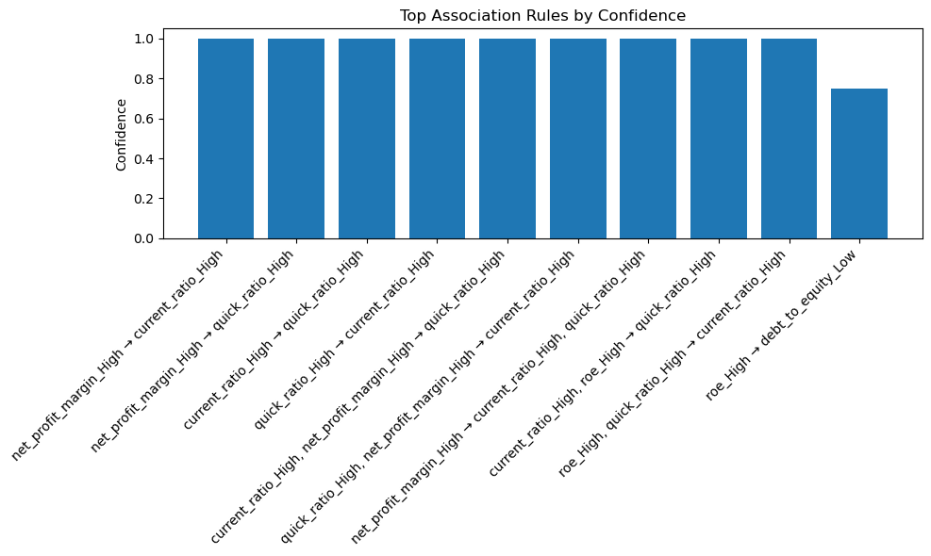

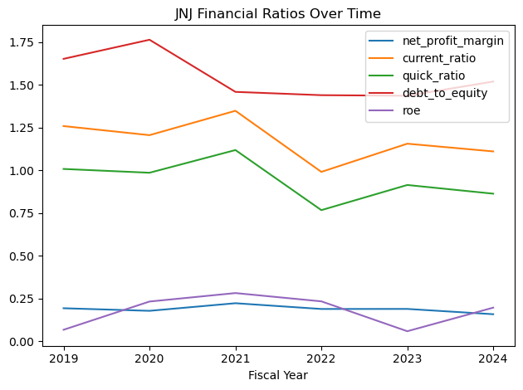

**Apriori Correlation Insights**

The patterns revealed by the Apriori association rules across the five companies show that liquidity metrics move together, such as the current ratio and quick ratio, which constantly moved in tandem across all companies. If one showed high liquidity, so did the other. That means the company not only has enough cash and receivables but also has healthy inventory levels. Another aspect is the inverse relationship between leverage and liquidity, because as we saw, companies generally had higher liquidity in years with lower debt-to-equity ratios. Apple, Microsoft, and Costco especially showed this trend. When companies had **less debt** (low debt-to-equity ratio), they usually had **more liquidity** (cash or short-term assets). Apple and Microsoft had more money available in years when they took on **less debt**. This matters because debt can help grow the business, but too much debt can squeeze liquidity. It also shows that there was a strong link between high net profit margins and high return on equity (ROE). When companies operated more efficiently (higher profits on sales), they also generated better returns for shareholders, as we saw with Apple and Microsoft, which were very profitable. They gave high returns to their shareholders, too. Lastly, some companies like FSS and JNJ showed patterns where strong liquidity occurred together with high net profit margins, indicating that efficient operations may directly lead to stronger cash positions. The final takeaway from this is that if both current and quick ratios are strong, the company is in great shape financially. Avoid overloading on debt unless it truly helps grow returns. Boosting profit margins is one of the most reliable ways to improve shareholder value.